EXPERIMENT 26:
Clone an existing GitHub repository to your local machine and make a small change in one of the files.
Tasks:
• Choose an existing public GitHub repository (e.g., your own or a sample repository).
• Clone the repository to your local machine using git clone <repository_url>
• Navigate into the cloned repository directory and open one of the files.
• Make a small edit, such as modifying a line of text or fixing a typo.
• Save your changes.
Step 1: Select a GitHub Repository
- Open the GitHub website and sign in to your account.
- Select an existing public repository (either your own repository or any public sample repository).
- Copy the HTTPS URL of the selected repository using the Code button.
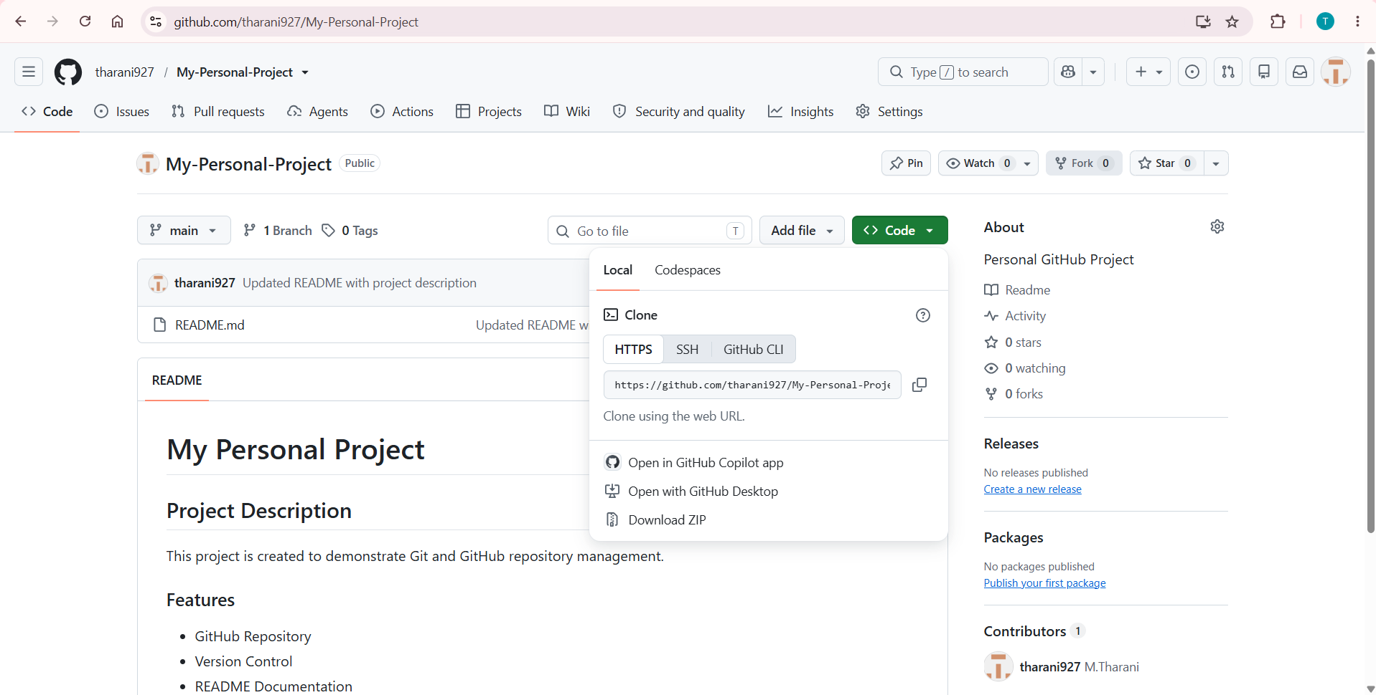
Step 2: Clone the Repository
- Open Git Bash or the terminal on your local machine.
- Clone the selected repository using the git clone command.
- Wait until the cloning process completes successfully.
- Verify that the repository has been downloaded to the local system.
git clone <repository_url>
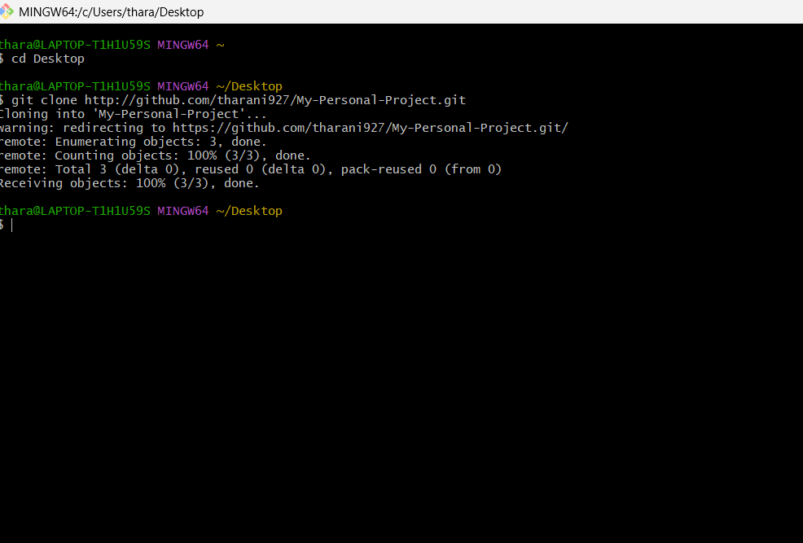
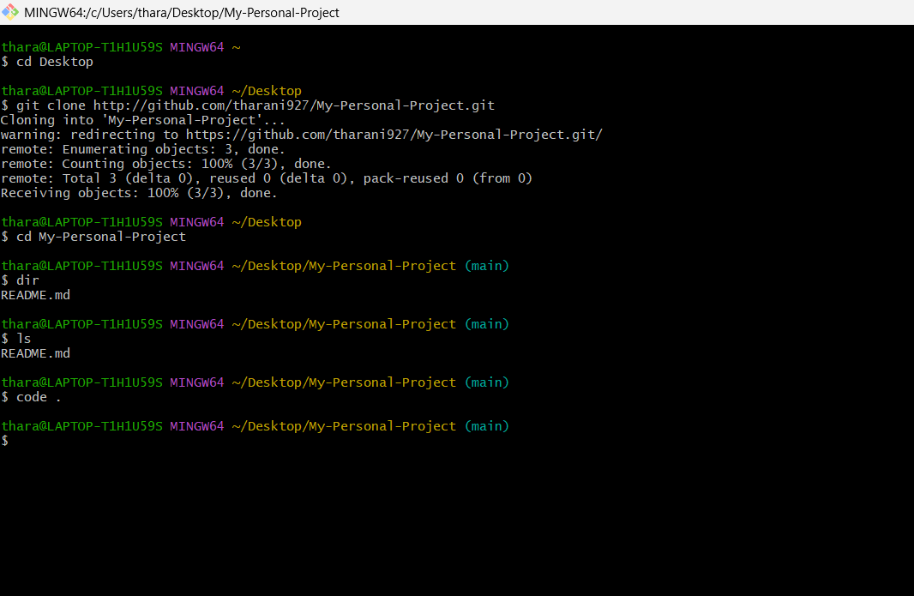
Step 3: Navigate to the Repository Directory
- Move into the cloned repository using the cd command.
- Verify that the repository files are available by listing the directory contents.
cd <repository_name>
Step 4: Open the Repository and Modify the File
- Open the cloned repository in Visual Studio Code or any preferred code editor.
- Locate the file that needs to be modified, such as README.md or any source code file.
code .
- Open the selected file.
- Make a small modification, such as updating a line of text, correcting a spelling mistake, or adding a short description.
- Save the modified file.
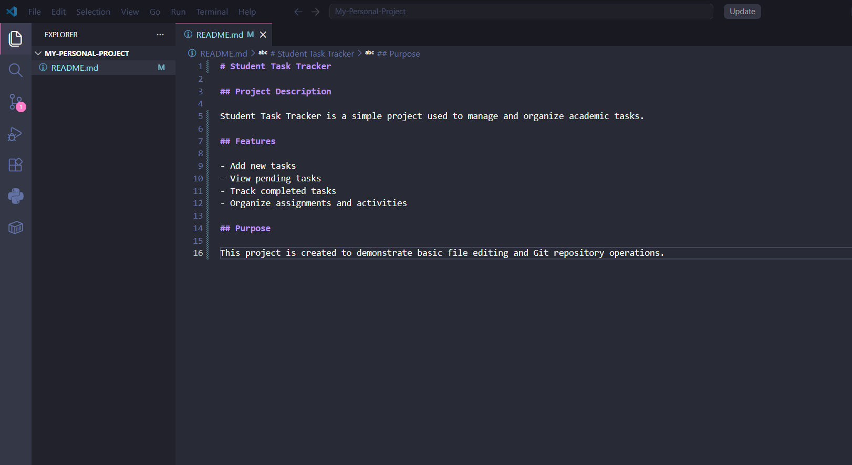
Step 5: Verify the Changes
- Return to Git Bash or the terminal.
- Check the repository status using the git status command.
- Verify that the modified file is displayed as changed.
git status
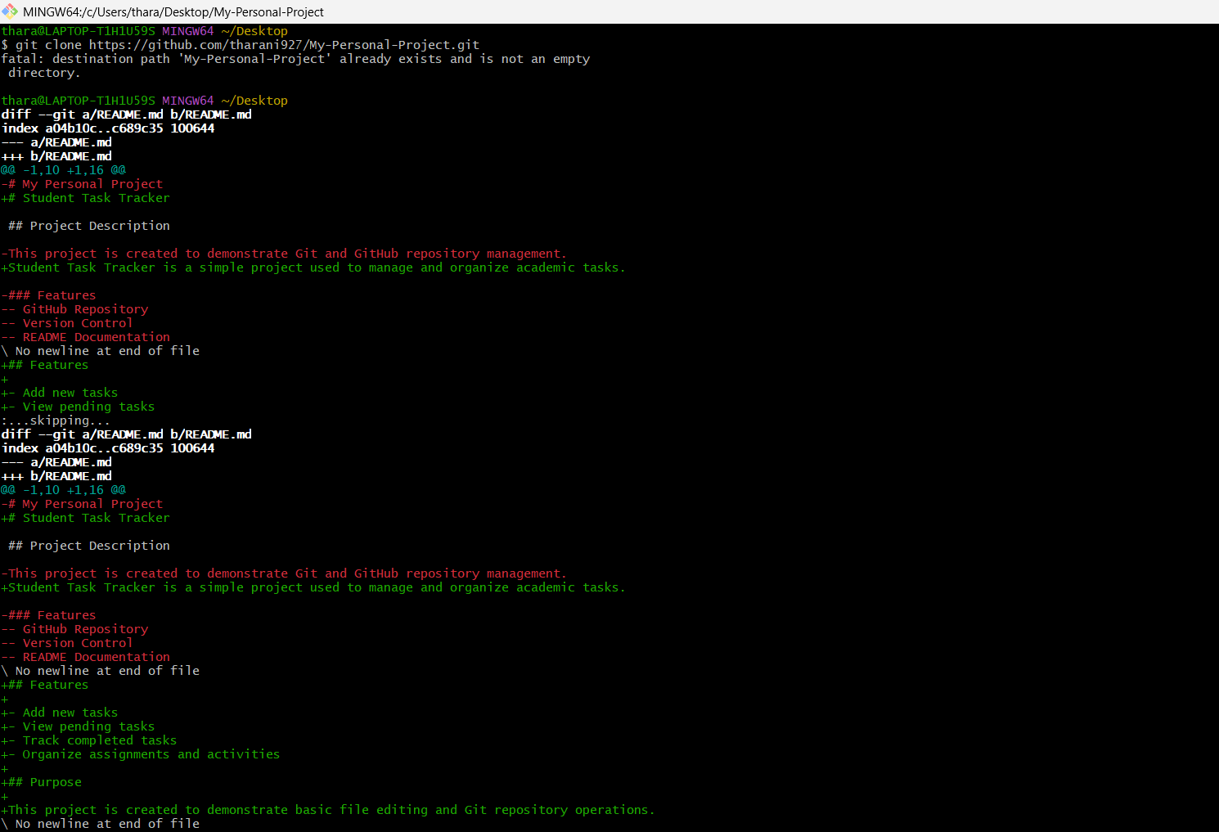
Step 6: Save the Updated File
- Ensure that all modifications have been saved successfully.
- Verify that the edited file is present in the local repository.

